Steps to Generate Tableau Server PAT for REST API

1. Navigate to <http://us-east-1.online.tableau.com/#/>
2. Enter your Bain Email in the “Username” section

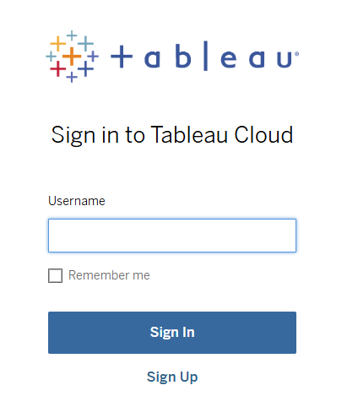

1. Enter URI  
   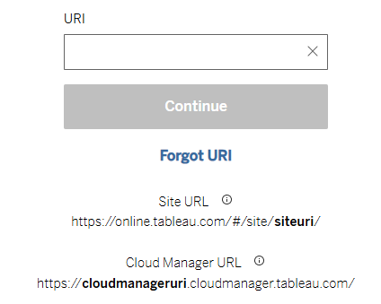
2. Click on your name icon on the top right section and select “My Account Settings”



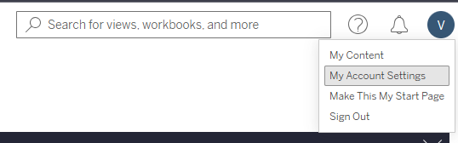

1. In the “Settings” section, scroll down the option where you see “Personal Access Tokens” and create a new token by giving it a suitable name. Note: do not share this token with anyone. This token will have the same access to the dashboards as you have on your Email ID. If you don’t have access to a dashboard on your Email ID, the token will also not be able to access it  
     
   